Flutter Programs — Expected Outputs
Weeks 1–9 • Flutter-style screen previews
Important: The screenshots below are faithful Flutter-style mockups generated from the source programs in the uploaded ZIP. They show the expected UI/output; they are not screenshots captured from a running Flutter emulator. Exact system status bars, font rendering, default Material colors, and API data spacing can vary by Flutter version/device.

Programs covered
- Week 1 — Dart basics / console output
- Week 2 — Text, Image, Container, Row, Column, Stack
- Week 3 — Responsive UI and screen-width layout
- Week 4 — Navigator and named routes
- Week 5 — Stateless/Stateful widgets, setState, Provider
- Week 6 — Custom widgets and themes
- Week 7 — Forms, validation, GlobalKey<FormState>
- Week 8 — AnimatedContainer, Rotation, Fade, Slide, Scale
- Week 9 — REST API fetching and meaningful UI

WEEK 1

Simple Dart Program
Console output produced by the Dart program.
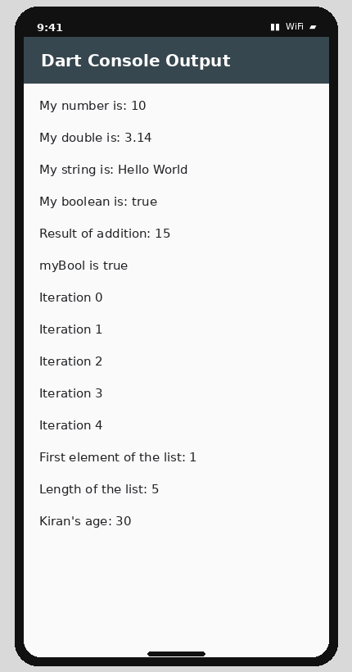
Expected Flutter output

WEEK 2

Text Widget
My First App → centered Text widget.
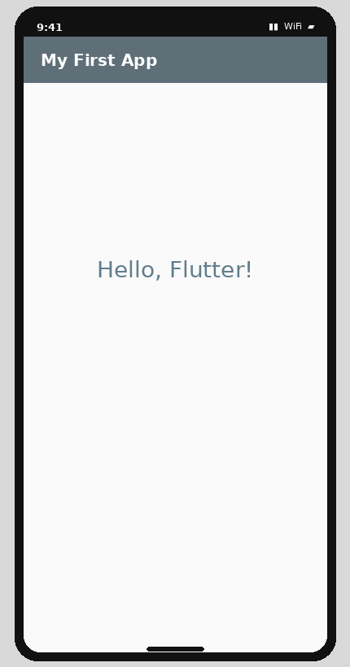
Expected Flutter output

Image Widget
Asset image area. The exact photo depends on the image supplied in the project.
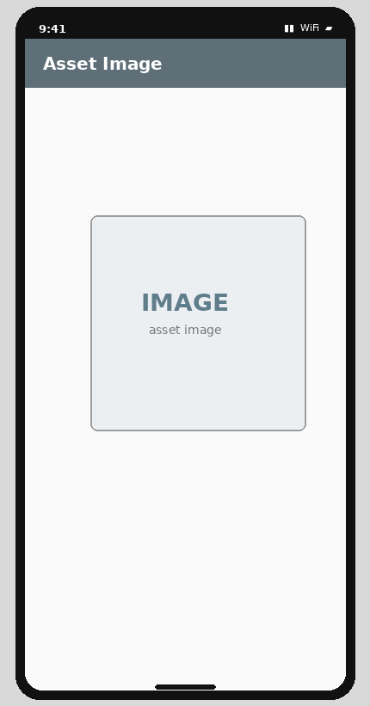
Expected Flutter output

Container
200 × 150 blue container with rounded corners and black border.
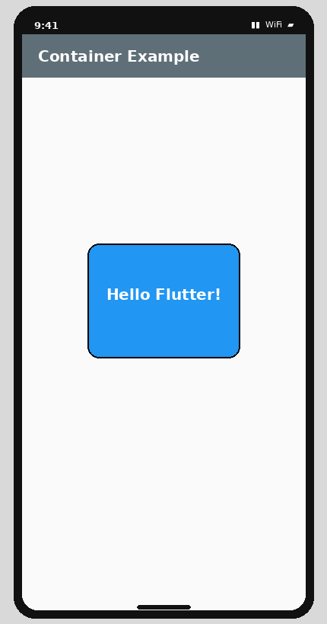
Expected Flutter output

Row Layout
Three 100 × 100 containers arranged horizontally.
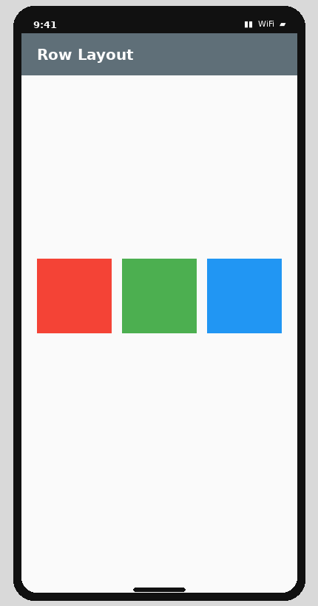
Expected Flutter output

Column Layout
Three 100 × 100 containers arranged vertically.
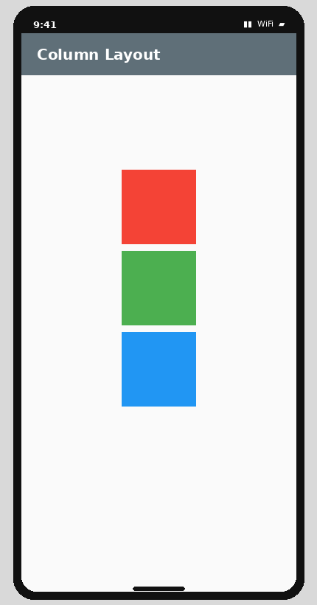
Expected Flutter output

Stack Layout
Three centered containers overlap: red 200×200, green 150×150, blue 100×100.
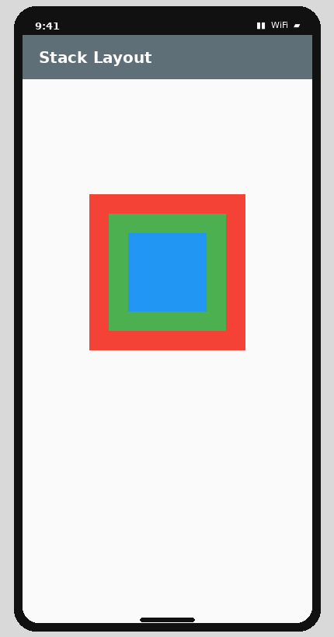
Expected Flutter output

WEEK 3

Responsive UI: Narrow
On a screen narrower than 600 px, the program builds the column layout.
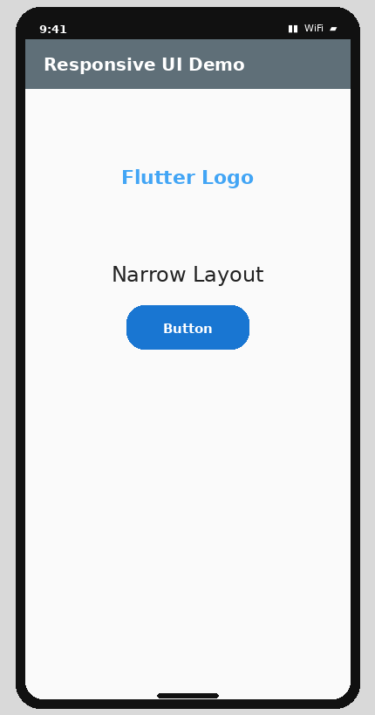
Expected Flutter output

Responsive UI: Wide
On a screen 600 px or wider, the program builds the row layout.
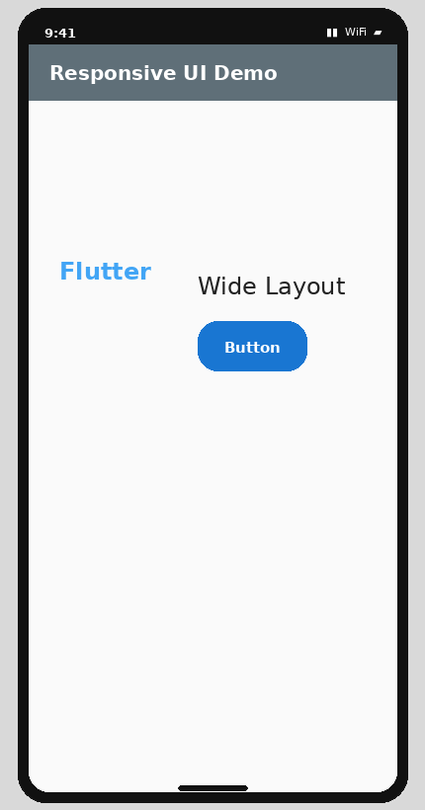
Expected Flutter output

Breakpoint/Media Query Output
The output changes according to the screen width; the source uses responsive breakpoints.
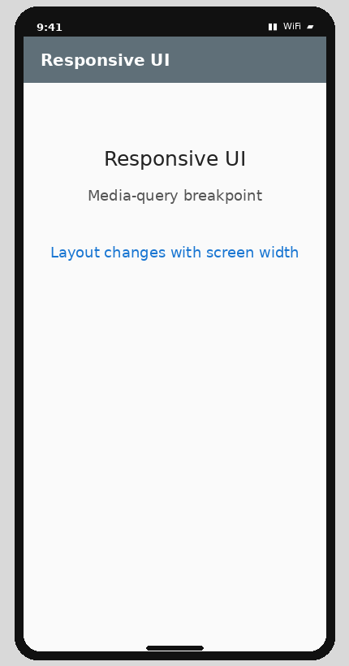
Expected Flutter output

WEEK 4

Navigator: First Screen
Initial screen.
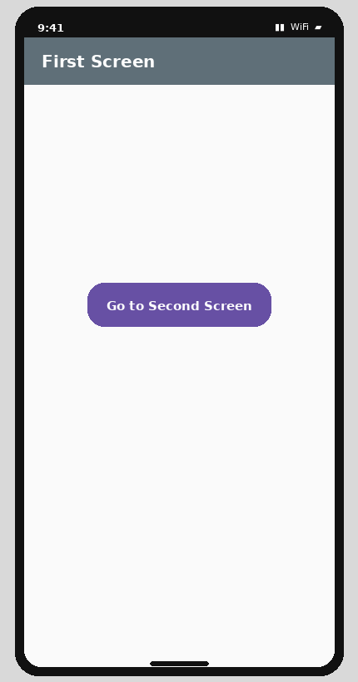
Expected Flutter output

Navigator: Second Screen
After pressing the navigation button.
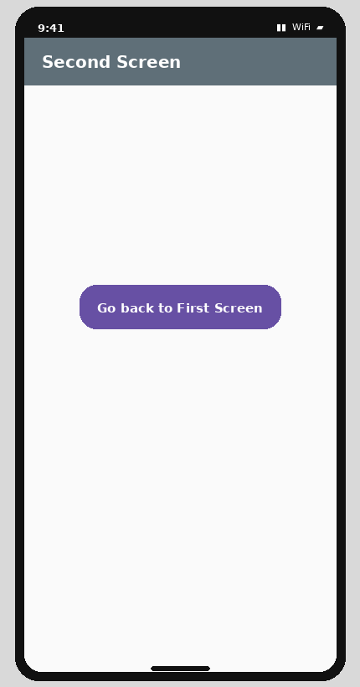
Expected Flutter output

Named Routes: Home
Initial named-route screen.
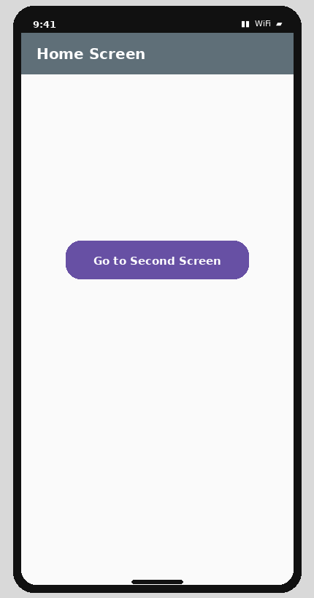
Expected Flutter output

Named Routes: Third Screen
After navigating Home → Second → Third.
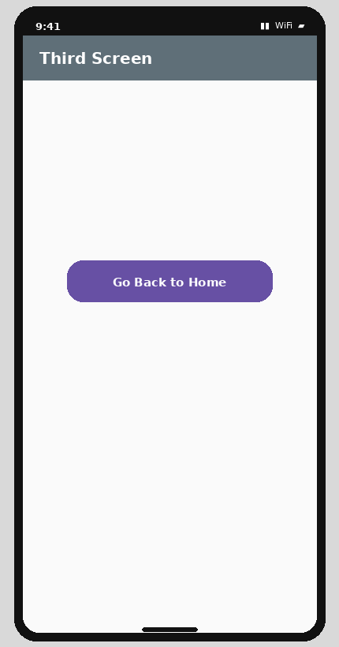
Expected Flutter output

WEEK 5

Stateful Widget Example
The supplied StatefulWidget example displays Hello, Flutter!.
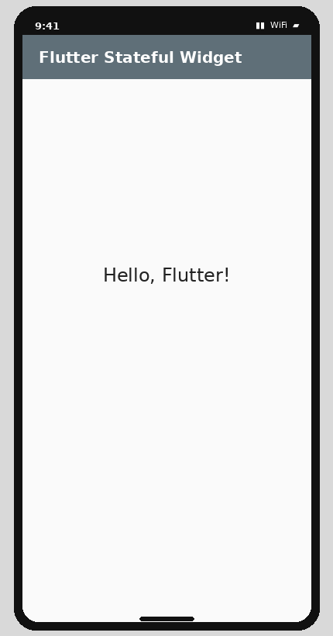
Expected Flutter output

setState Counter
Initial state. Press + to increase the counter.
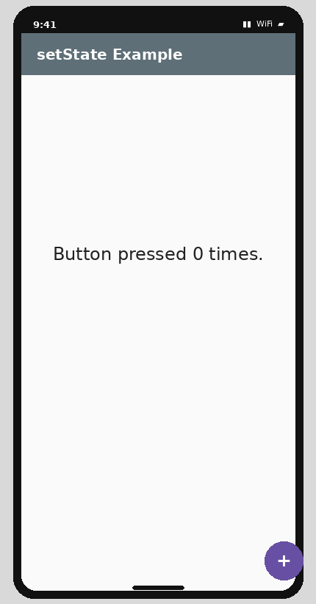
Expected Flutter output

Provider Counter
Initial Provider state. Press + to increment.
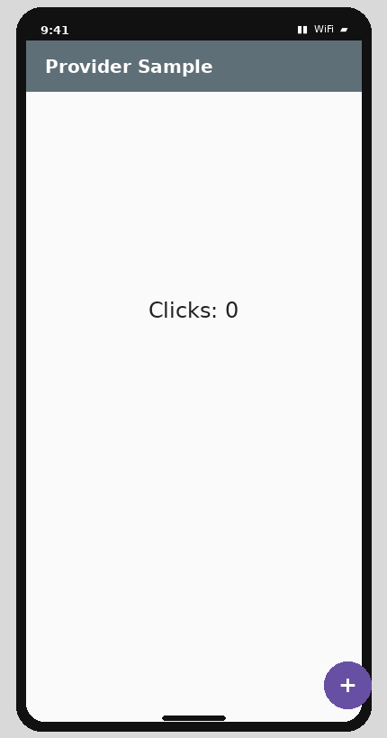
Expected Flutter output

WEEK 6

Custom Widgets
Dashboard showing reusable CustomUserAvatar widgets.
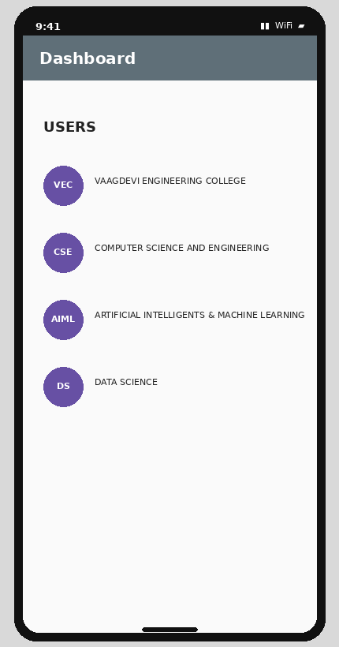
Expected Flutter output

Theme & Custom Styles
Themed Dashboard with styled profiles, colors and typography.
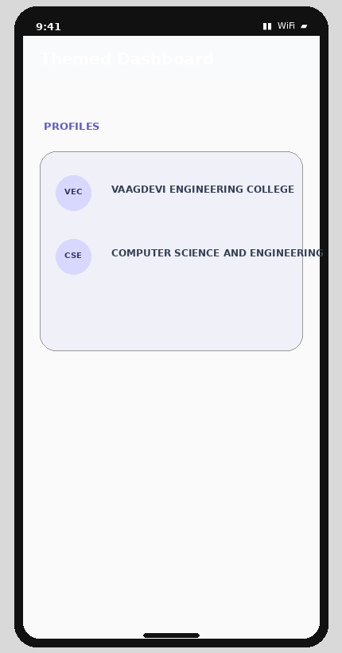
Expected Flutter output

WEEK 7

Basic Form
Initial form screen.
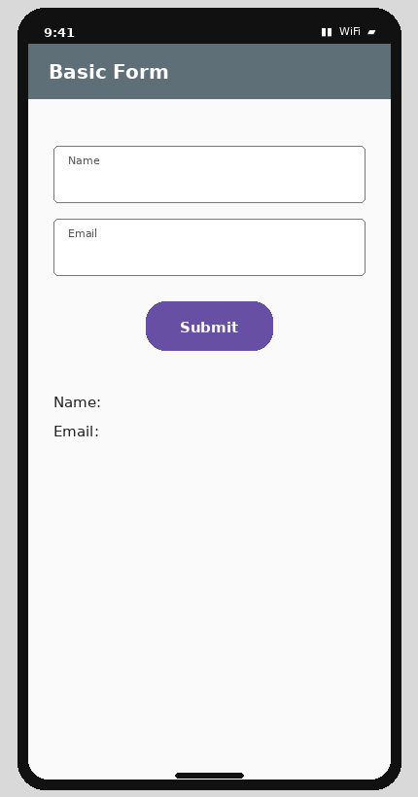
Expected Flutter output

Form Validation
Example of the error state after submitting empty fields.
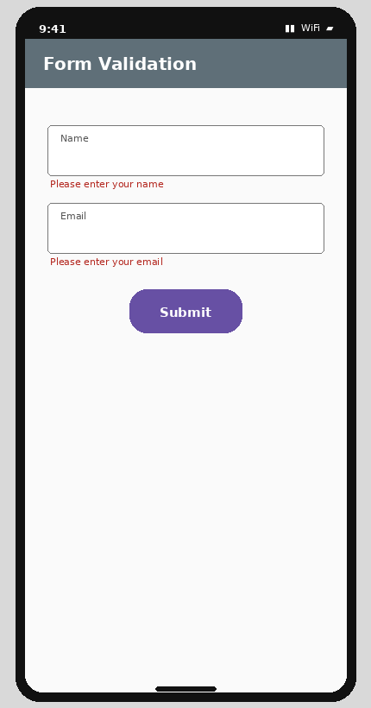
Expected Flutter output

GlobalKey<FormState> Login
Initial login form; validation errors and SnackBars appear after submission.
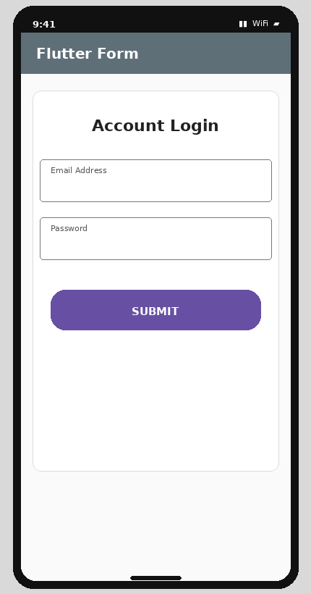
Expected Flutter output

WEEK 8

AnimatedContainer: Initial
Initial state. Tapping the box animates it to 250×250, blue, rounded 50.
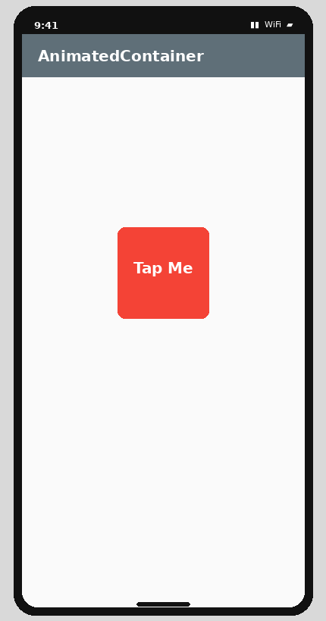
Expected Flutter output

AnimatedContainer: After Tap
After tapping, the box expands and changes color/shape.
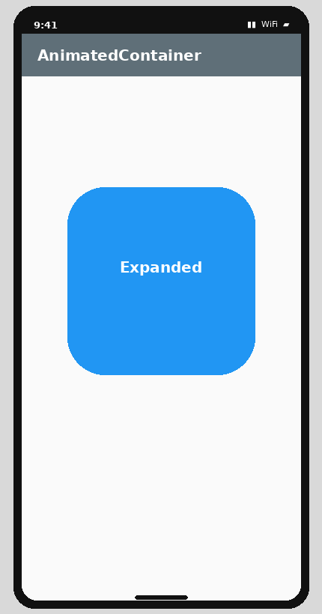
Expected Flutter output

Rotation Animation
Initial state; the purple settings icon rotates for 2 seconds when refresh is pressed.
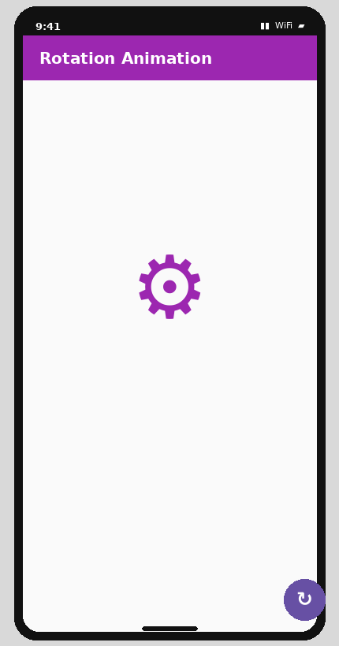
Expected Flutter output

Fade Animation
Visible state. Pressing the visibility FAB fades the blue box out/in.
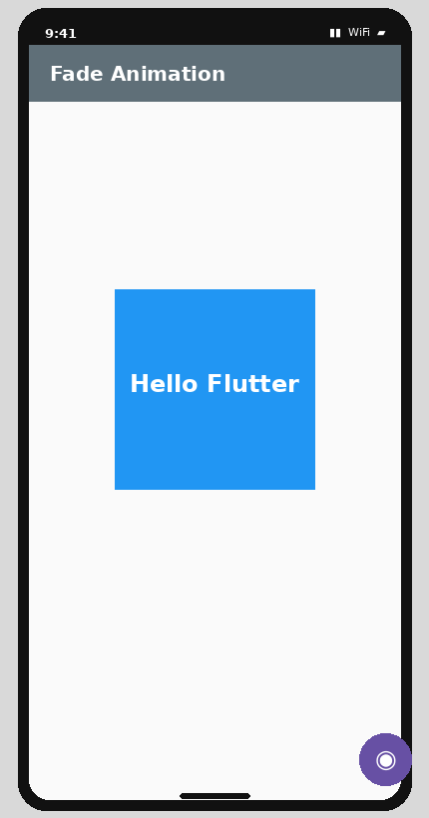
Expected Flutter output

Slide Animation
After animation, the teal box is centered; it starts from the left and slides in.
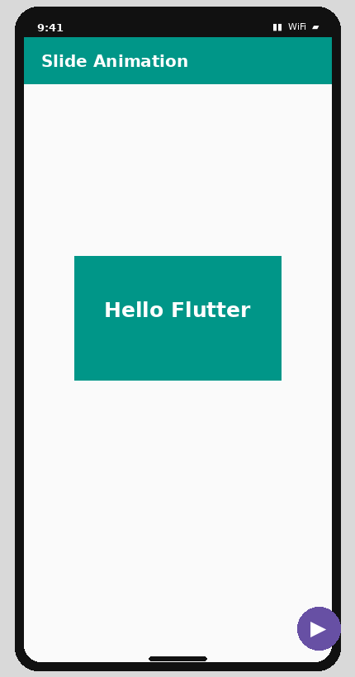
Expected Flutter output

Scale Animation
The heart scales from 1.0× to 2.0×; pressing the FAB reverses it.
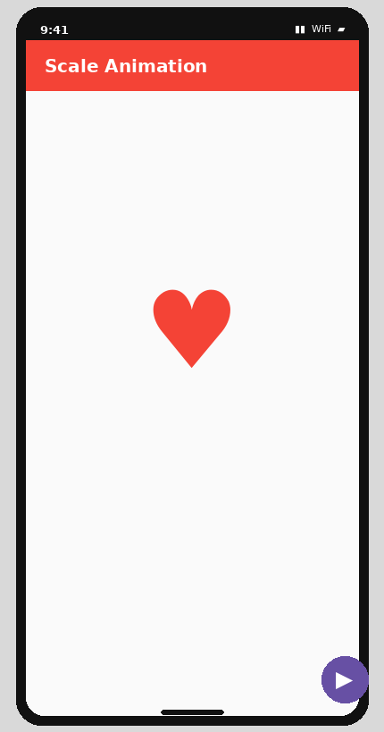
Expected Flutter output

WEEK 9

REST API: Loading
While waiting for the HTTP request, FutureBuilder shows a CircularProgressIndicator.
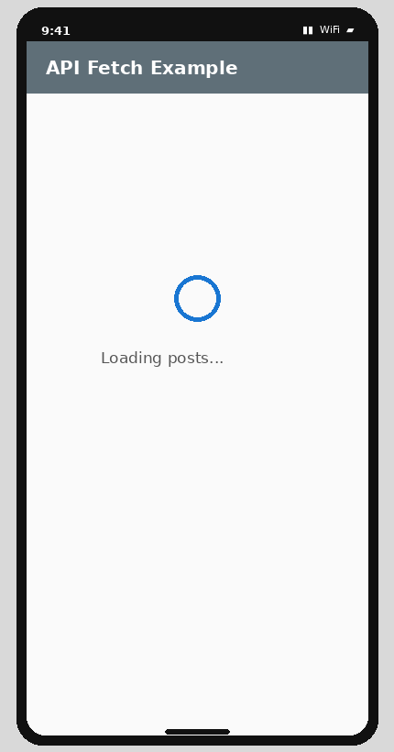
Expected Flutter output

REST API: Fetched List
Successful response: posts are displayed in ListView/ListTile form.
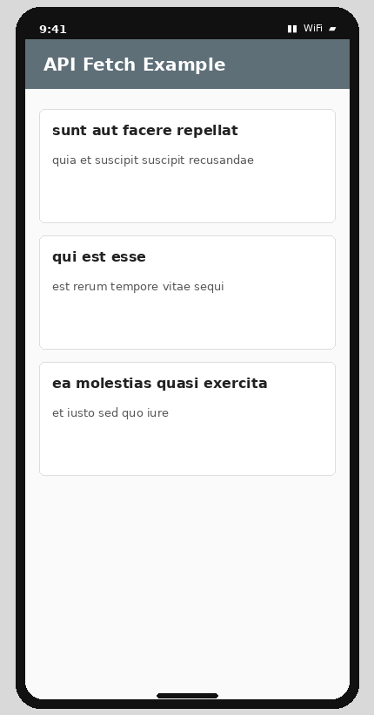
Expected Flutter output

Meaningful UI: Cards
The second Week-9 program wraps each fetched post in a Card with title and body.
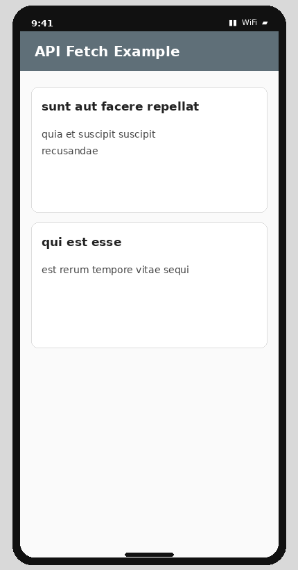
Expected Flutter output

Interaction / Output Summary
Week | Program | What you see / do
1 | Dart basics | Console prints variables, arithmetic, condition, loop, List and Map values.
2 | Widgets & layouts | Text/image/container and Row/Column/Stack layouts appear on screen.
3 | Responsive UI | Narrow screen shows a Column; wide screen shows a Row.
4 | Navigation | Buttons move First → Second and Home → Second → Third.
5 | State management | Counter text changes from 0 upward when + is pressed.
6 | Custom widgets/themes | Dashboard profiles appear with reusable avatars and styling.
7 | Forms | Input fields accept data; invalid input shows errors; valid submission shows SnackBar.
8 | Animations | Boxes/icons fade, slide, rotate, scale, or resize after interaction.
9 | REST API | Loading indicator appears, then posts are fetched and displayed.

